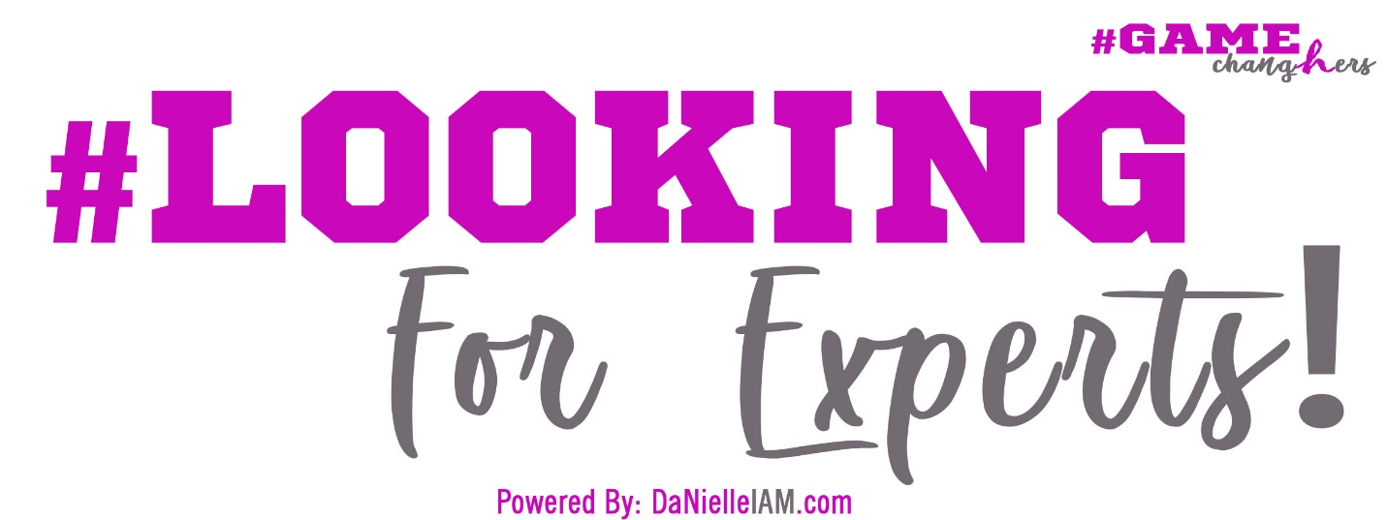

Dear Expert:

First of all, I’d like to introduce myself. My name is Da’Nielle Veasey or known as DaNielleIAM, and I am the CEO/Owner of UB4ME Business Consulting & Marketing Firm, the Woman behind the “IAM the Change Movement” and the Founder and Organizer of “The Game ChangHers”, which is a community of support for Women in Business that are looking for help in areas that will CHANGE Her Game in Life….in Order to CHANGE the Game in Her Business! My Vision for this is SO HUGE, that I wouldn’t dare think that I can do this alone! I am looking for Women in Business that have a Passion to Serve others by teaching, speaking, mentoring, motivating, educating, etc…just plain old giving back, as well as ready to Receive the same benefits in return in order to help women in business evolve better in life, so that we can better evolve in our businesses and began to reach the Platforms and the Profits that I KNOW God has for each of us! There will definitely be opportunities for pay, but mostly, I am again, looking for those that believe in paying it forward with our God-given Gifts and Purposes, while understanding that if you “Build the People First, then the People will Build Your Business”, and that we will definitely see an Increase! Thank you for your interest in supporting this vision, and if you find that this is something you’d LOVE to be a part of, then YEP…YOU ROCK, and WE WANT YOU! But here’s the thing, this is very strategic and purposeful, in meaning, I am looking for ALL things that will help ChangHER, so if you have topics to share in your area of Expertise that will encourage and push that Change in Her, then head on over to the website at TheGameChangHers.com, sign up and fill out the ‘ChangHer Expert Application’ and Submit it, and myself or someone will be getting back with you to schedule a 1-on-1. We are super excited to have you apart of The ChangHER Academy, and we Welcome you and your expertise in advance!

Sincerely,
Da’Nielle Veasey

